Project tittle: The Impact of Technology on Everyday Life

Introduction

Technology has become an integral part of our everyday lives, impacting everything from how we communicate to how we work and play. Understanding the impact of technology on everyday life is important for several reasons.

First, technology has the potential to improve our lives in countless ways, from making everyday tasks easier to connecting us with people around the world.

However, technology also has the potential to create new challenges and problems, such as privacy concerns and the potential for addiction.

By studying the impact of technology on everyday life, we can better understand how to use technology in ways that benefit us and society as a whole.


History of Technology

Technology has been evolving for centuries, with key milestones including the invention of the printing press, the telephone, and the internet.

Each of these technologies had a profound impact on everyday life, changing the way we communicate, access information, and interact with the world around us.

For example, the printing press allowed for the mass production of books and other written materials, making knowledge more accessible to the general public.

The telephone revolutionized communication, allowing people to speak with each other over long distances.

And the internet has transformed the way we access information, connect with others, and engage in commerce.

Current State of Technology

Today, technology is more integrated into our lives than ever before. Key technologies that are impacting everyday life include smartphones, artificial intelligence, and social media.

Smartphones have become ubiquitous, allowing us to communicate, access information, and entertain ourselves from anywhere at any time.

Artificial intelligence is being used in a variety of applications, from virtual assistants to self-driving cars.

And social media has transformed the way we communicate and share information, allowing us to connect with people around the world in an instant.

While these technologies have many benefits, they also have drawbacks. For example, smartphones can be addictive, leading to decreased productivity and increased stress.

Artificial intelligence has the potential to displace workers, leading to job loss and economic uncertainty. And social media has been linked to mental health issues, such as depression and anxiety.

Future of Technology

Emerging technologies and trends that have the potential to impact everyday life in the future include virtual and augmented reality, the Internet of Things, and 5G networks.

Virtual and augmented reality have the potential to transform entertainment, education, and training.

The Internet of Things has the potential to make our homes and cities more connected and efficient.

And 5G networks have the potential to increase the speed and reliability of wireless communication.



Case Studies

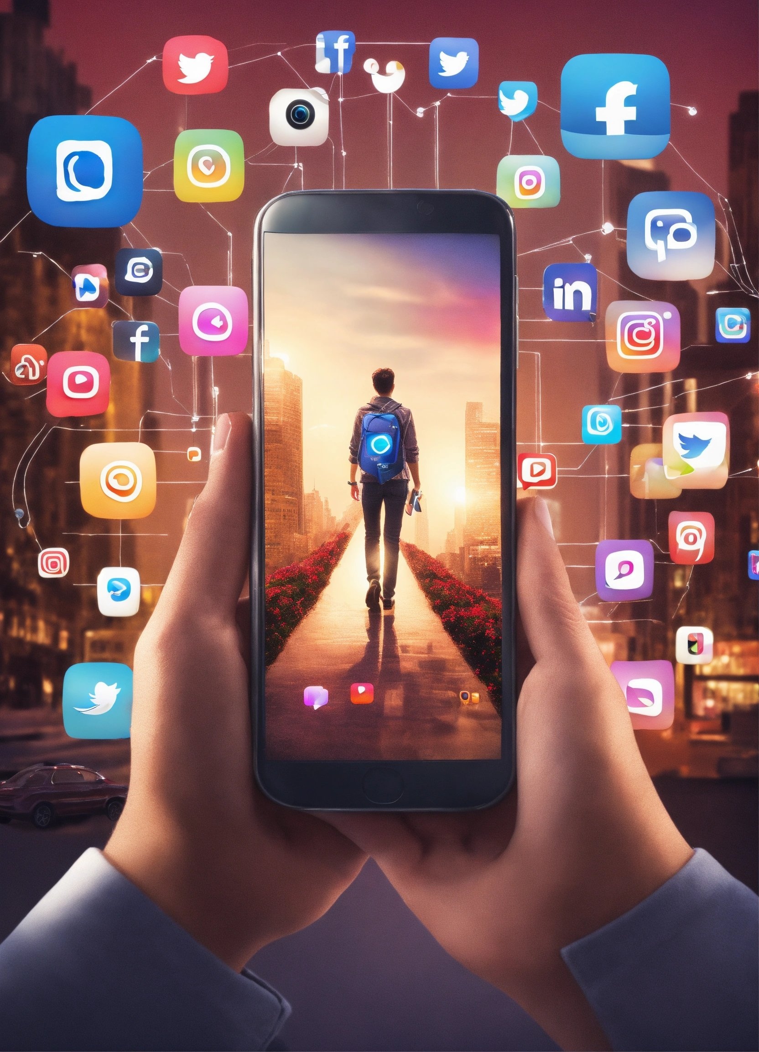
Case Study 1: Smartphones and their impact on communication and social interaction

Smartphones have become an essential part of our daily lives, with many of us checking our phones dozens of times a day.

While smartphones have many benefits, such as allowing us to stay connected with others and access information on the go, they can also have negative impacts on communication and social interaction.

For example, studies have shown that people who use their smartphones during face-to-face conversations are perceived as less engaged and less empathetic.

Additionally, excessive smartphone use has been linked to decreased attention span and increased stress.

Case Study 2: Artificial intelligence and its impact on the job market

Artificial intelligence has the potential to transform the job market, with some predicting that up to 40% of jobs could be automated in the coming decades.

While this has the potential to create new jobs and increase productivity, it also has the potential to displace workers, leading to job loss and economic uncertainty.

It is important to consider the ethical implications of artificial intelligence and ensure that its benefits are shared fairly across society.

Case Study 3: Social media and its impact on mental health

Social media has transformed the way we communicate and share information, but it has also been linked to mental health issues, such as depression and anxiety.

Studies have shown that people who use social media excessively are more likely to experience negative mental health outcomes, such as decreased self-esteem and increased feelings of loneliness and isolation.

It is important to consider the impact of social media on mental health and take steps to promote responsible use.

Conclusion

In conclusion, technology has had a profound impact on everyday life, with both benefits and drawbacks. By understanding the impact of technology on everyday life, we can make informed decisions about how to use technology in ways that benefit us and society as a whole. It is important to consider the ethical implications of technology and ensure that its benefits are shared fairly across society. Additionally, it is important to promote responsible use of technology to mitigate its negative impacts.

